            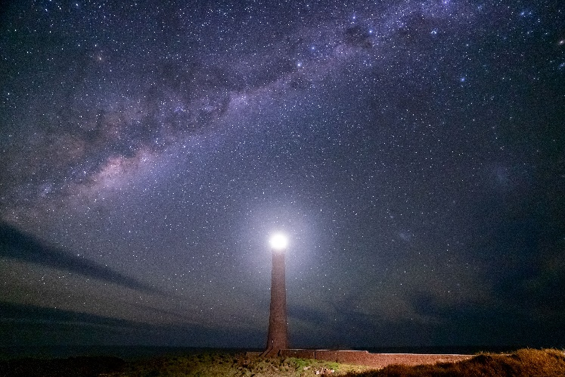

**Program for term 3, August - September 2024**

Regular weekly events:

* Wednesdays, 3-4:15pm, current affairs discussion group with afternoon tea in the church meeting room
* Wednesdays, Mah-jong, contact group leader for details

Regular monthly events:   Community Clubrooms, 2pm for a cuppa, 2:20pm start

* Friday **2 August**, Larry Gray: “The Trials of a Greenland Kayak Expedition”
* Friday **6 September** , Tracey Johnston: “Mallacoota Fire Brigade: what it is about”

Other events, watch our Facebook page for details:

* Pickleball by arrangement with Mallacoota Youth & Sports Club, 10am Mondays during school term
* Star gazing telescope handling and viewing nights in a street near you: let us know if your street has minimal street lighting so we can set up a star gazing event in different places around Mallacoota, and stay tuned to social media for clear skies and events near you..
* *Plant walks will resume later in August : watch FB group for details!*

            

​​​

Website: u3amallacoota.org.au